1. 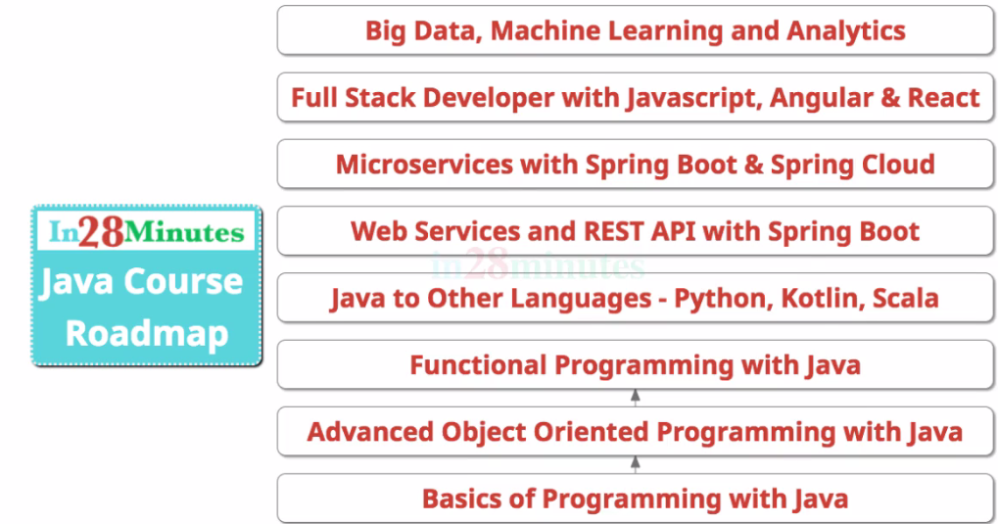
2. 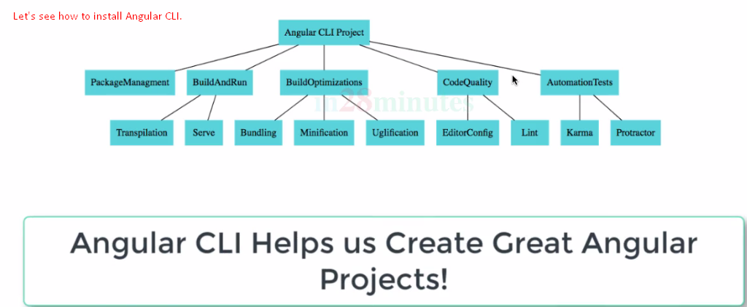
3. 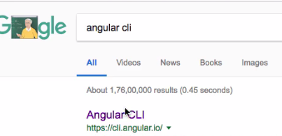 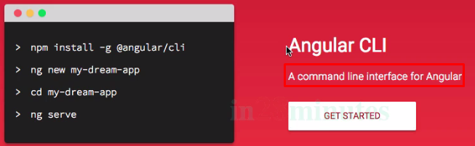
4. Angular CLI not only helps to create angular app but angular code while developing angular app.  
   It helps us to run our app locally and to run unit test and integration test.
5. To install Angular CLI is very easy.
6. 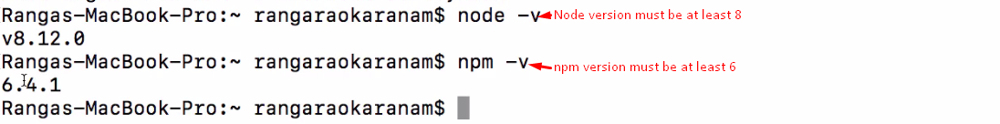
7. Angular CLI is present as module. 
8. 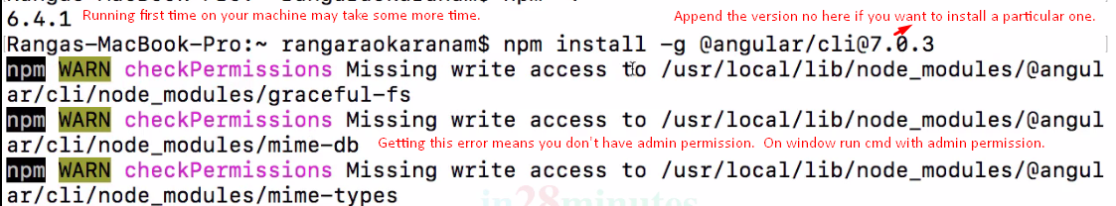
9. 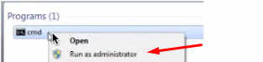 
10. 
11. 
12. 